**Nested looping(excutive pipeline),To merger multiple folder to single folder**

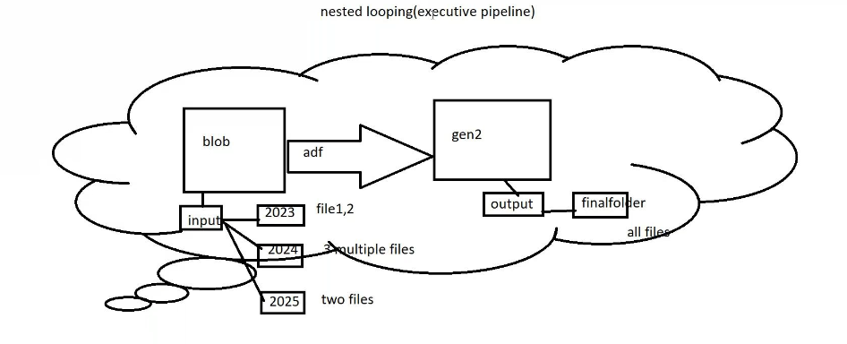

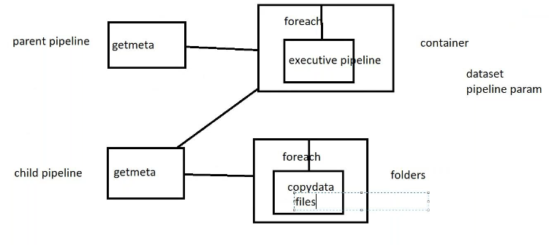

**Create a blob storage:** In multiple folder in that multiple file

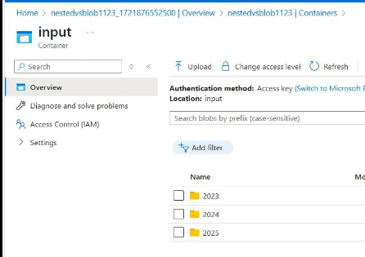

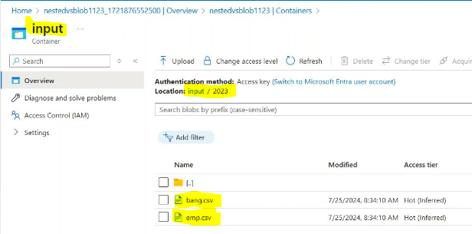

Create gen2 storage: create output container

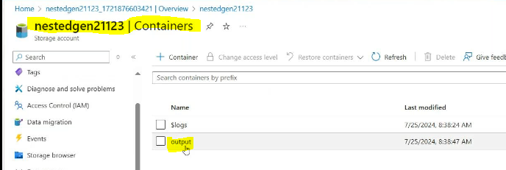

Create adf:

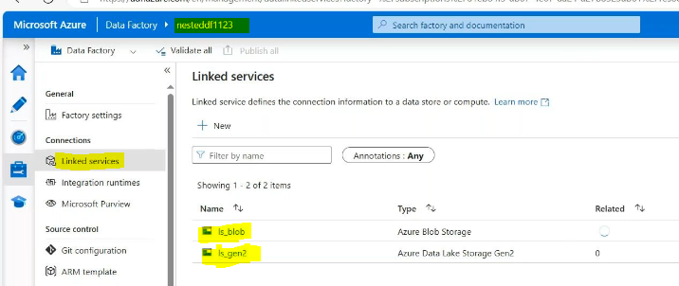

Create a dataset source side:

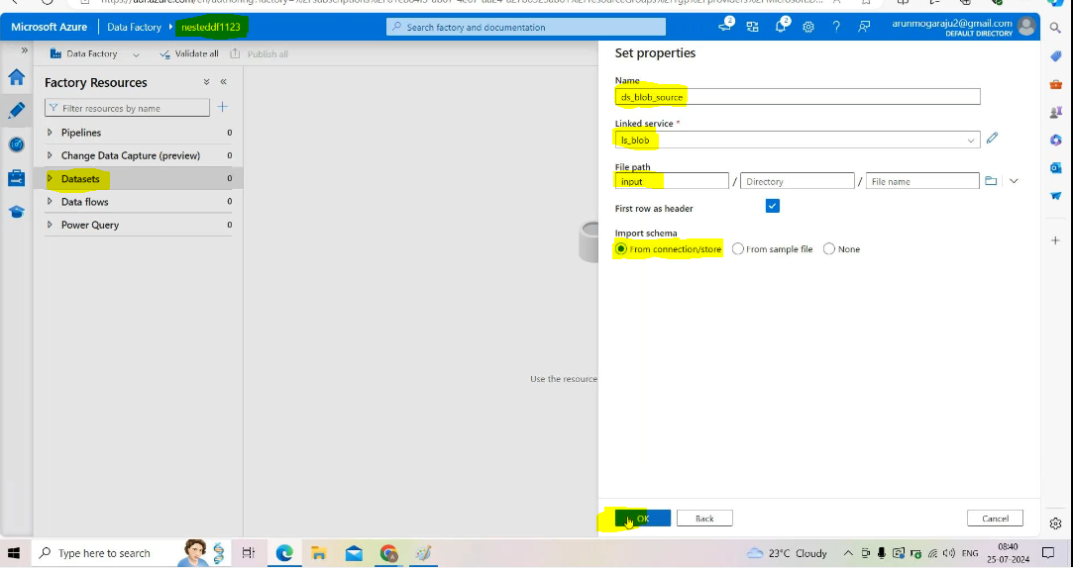

Create dataset sink side :

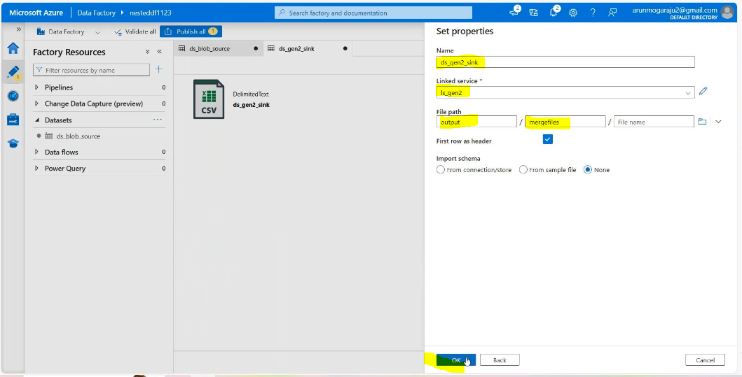

Create 2 pipelines :

Parent pipeline:it will read the container level

Child pipeline: it will read the folder level

Go to child pipeline;

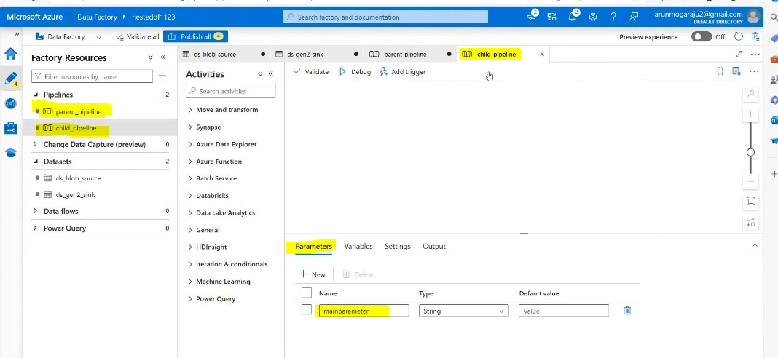

Go to paranet pipeline: create a dataset for get metadata activity

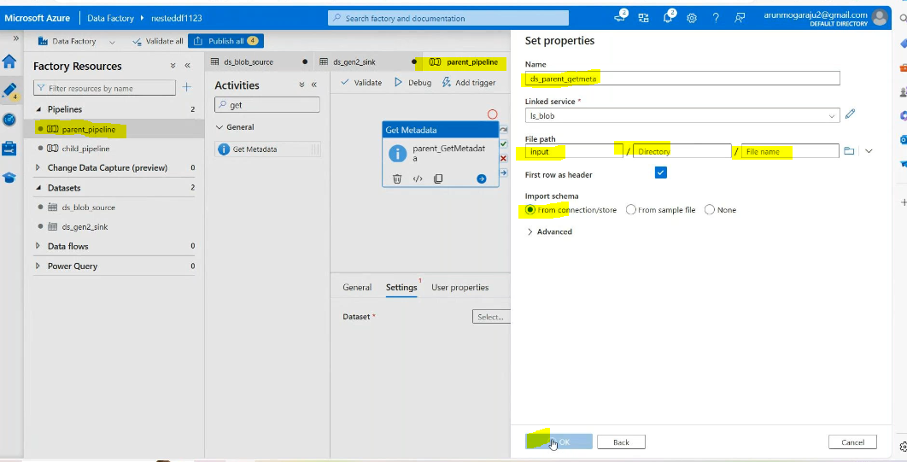

Then add child items:

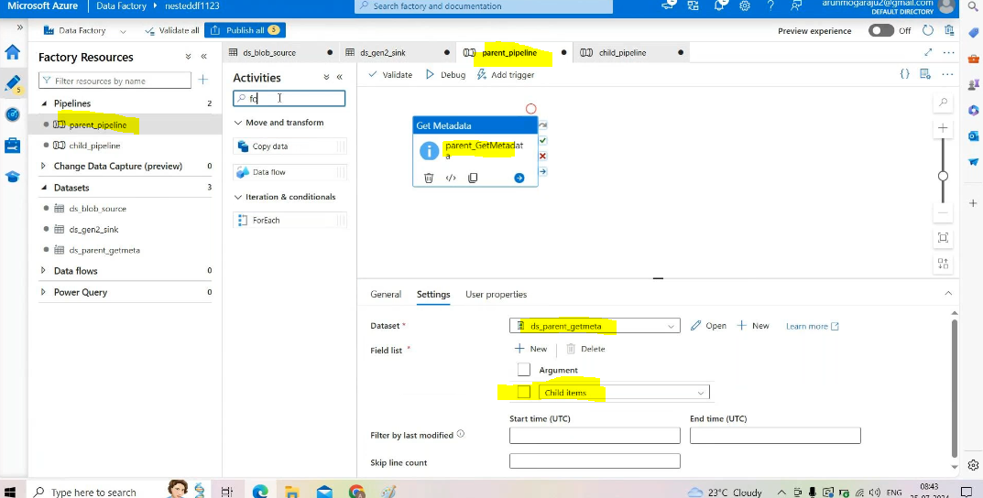

Then drag and drap the foreach activity in settings add child items in foreach

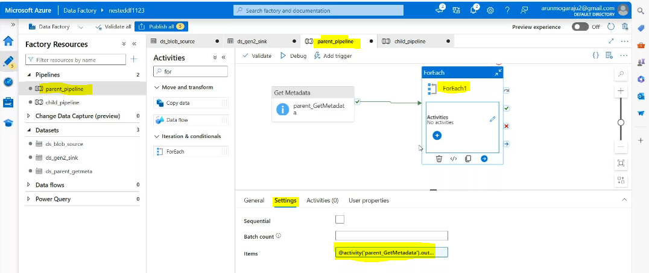

In side foreach we doesn’t copy the foreach ->that’s way we go for the excitive pipeline

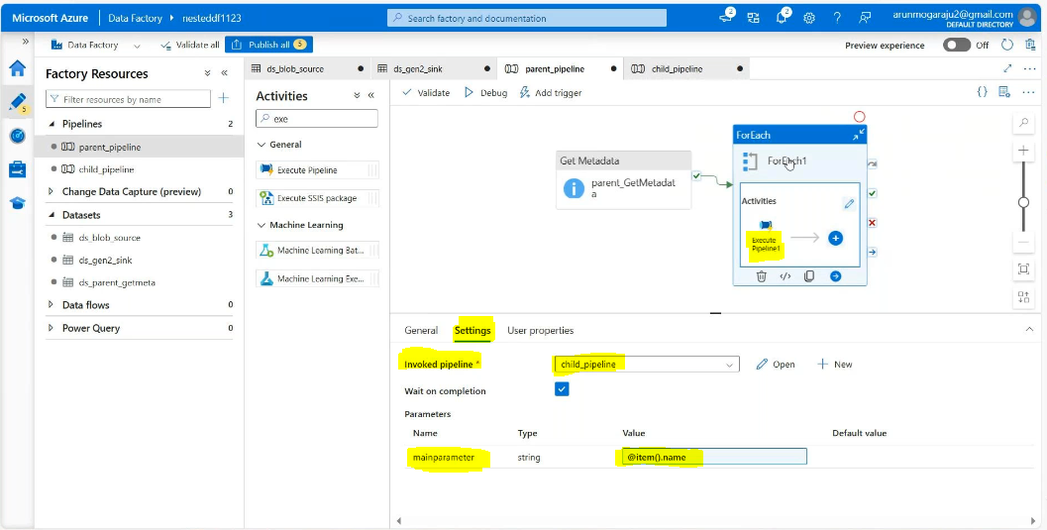

Go to child pipeline 🡪getmetadata activity🡪create a data set for getmetadata activity

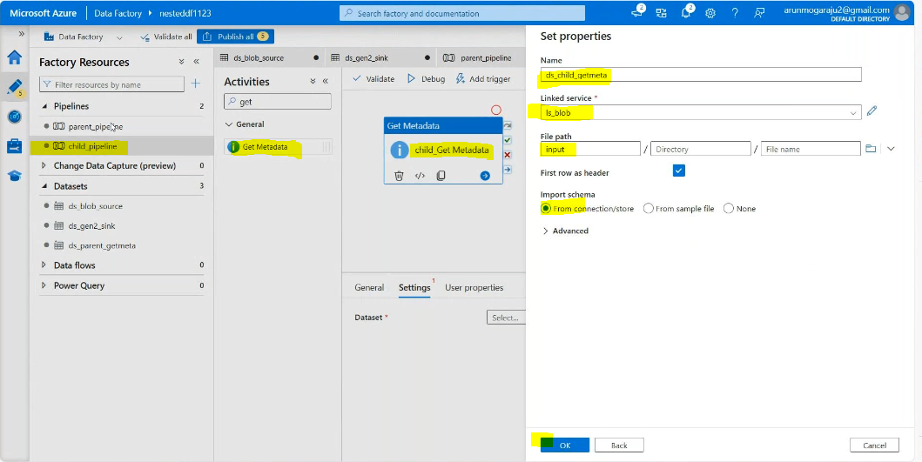

Go to that dataset🡪

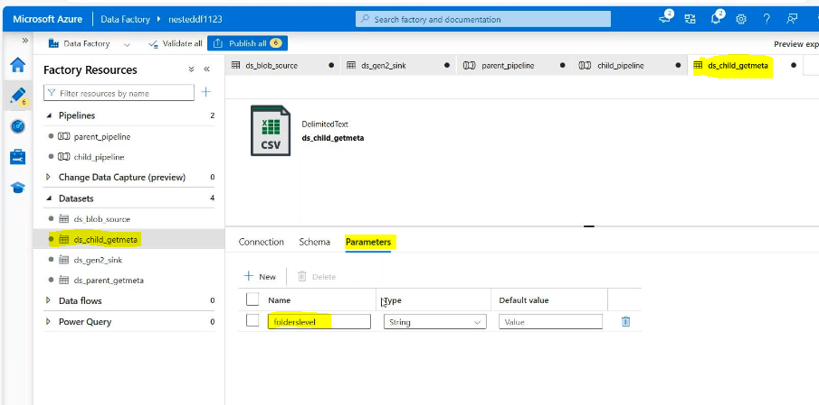 connection:

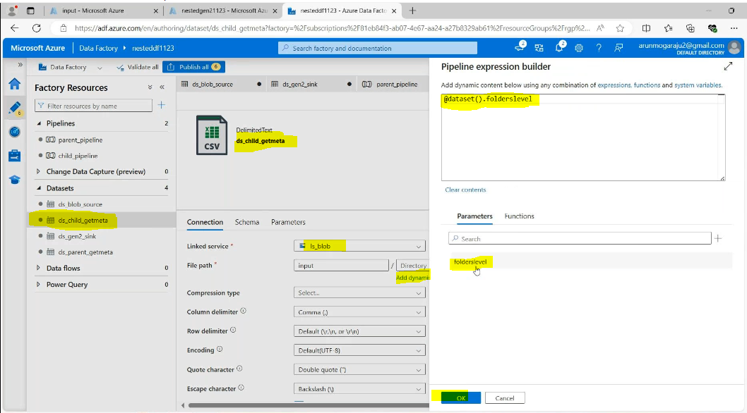

G to chiled pipeline level:

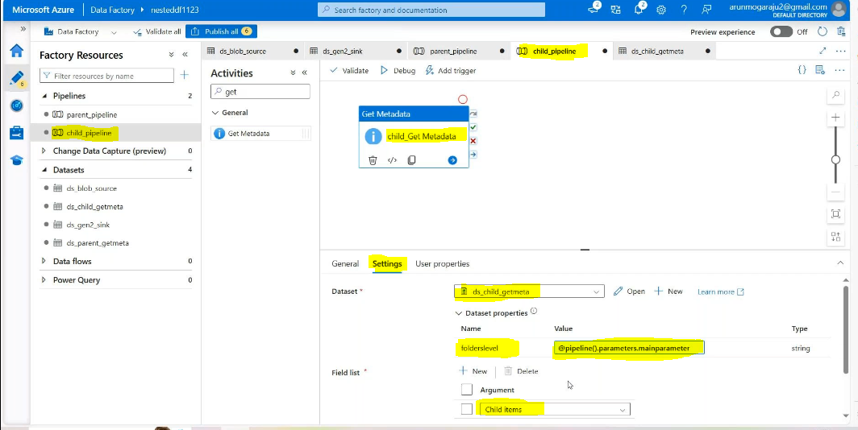

Then drag and drop the for each :

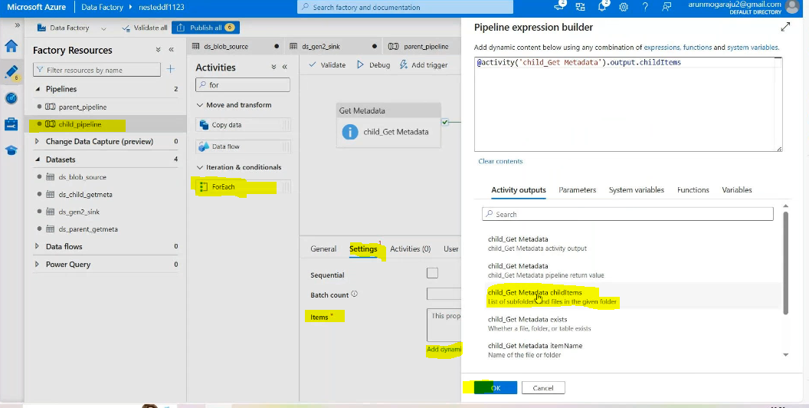

Then in side foreach copy the activity source side:

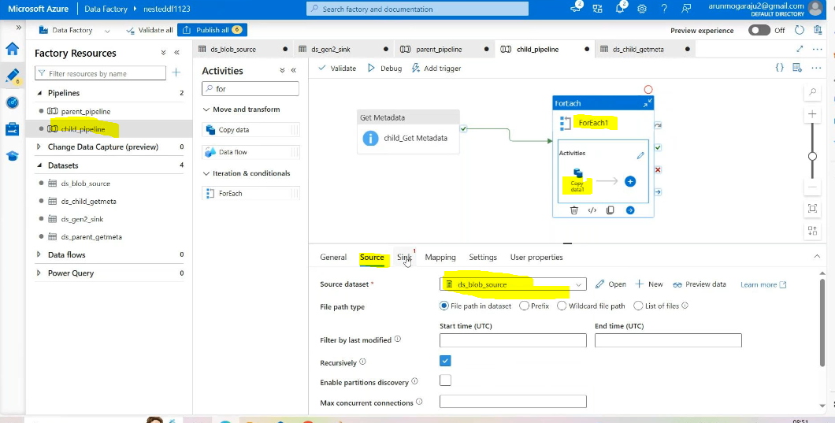

Open the source_dataset source need to add parameters:

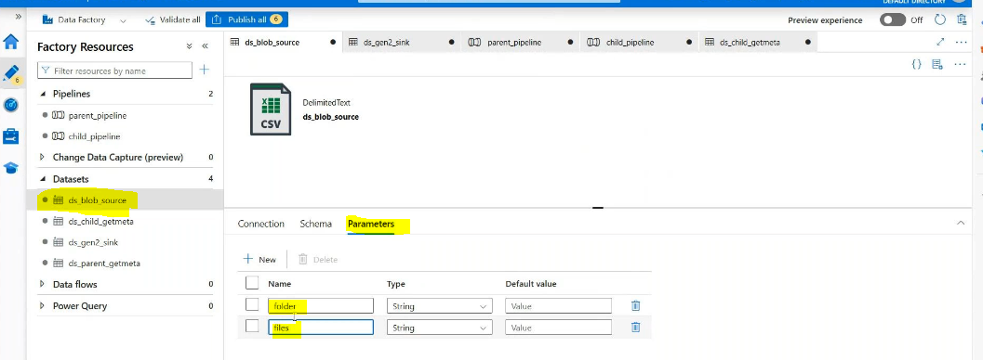

Connection:

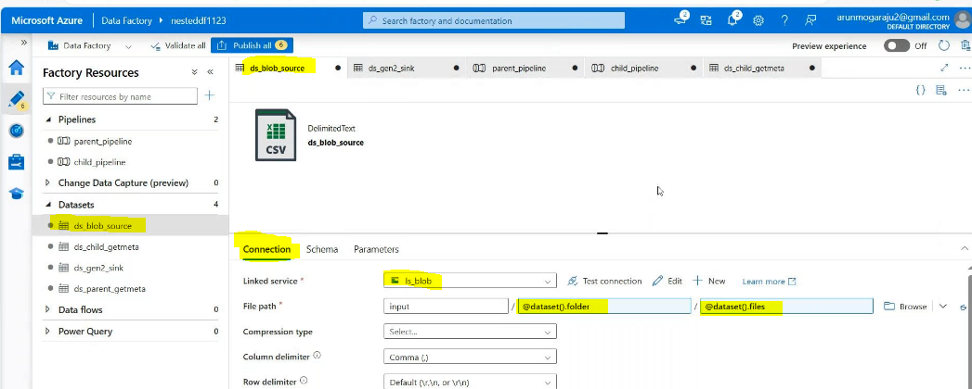

Chiled _pipeline source side:

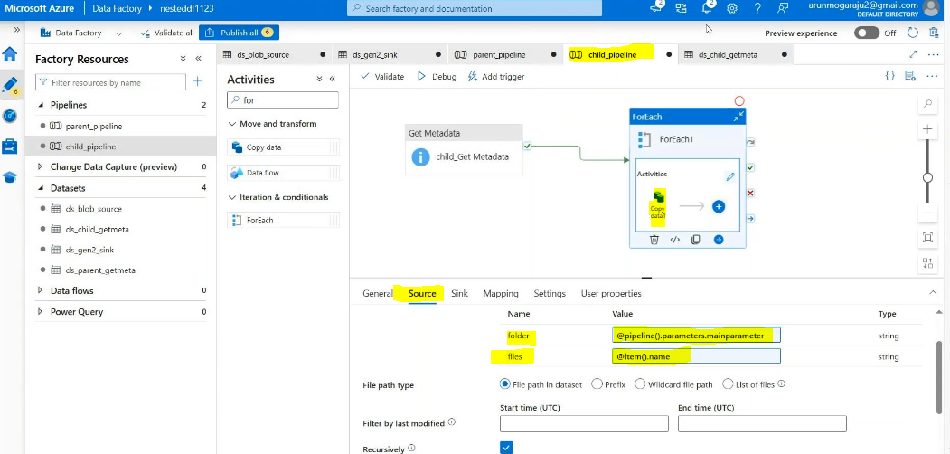

Open the sink side dataset need to add parameters:

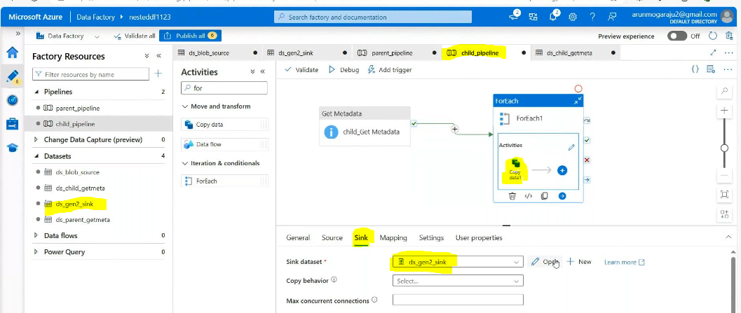

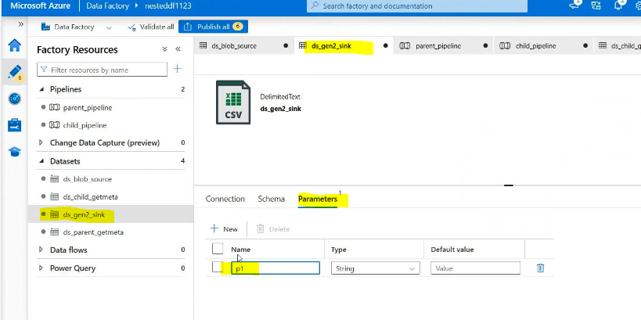

Conections:

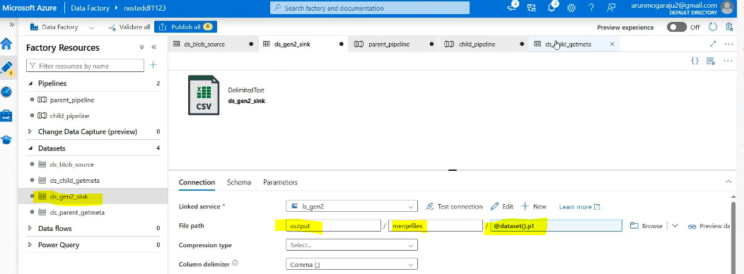

Child pipeline level:

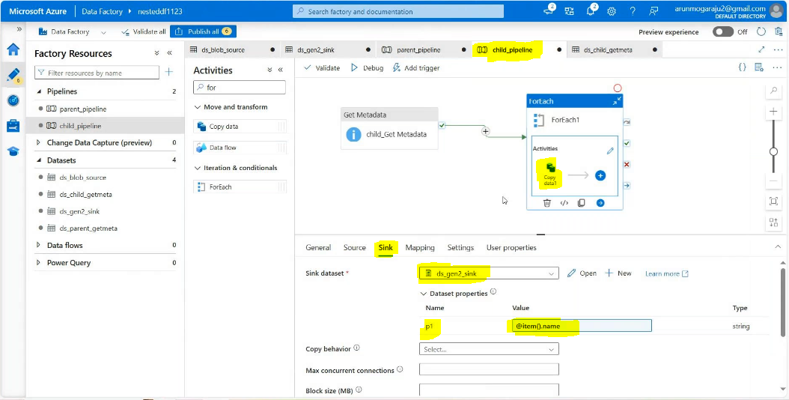

Validate and debug:

Result:

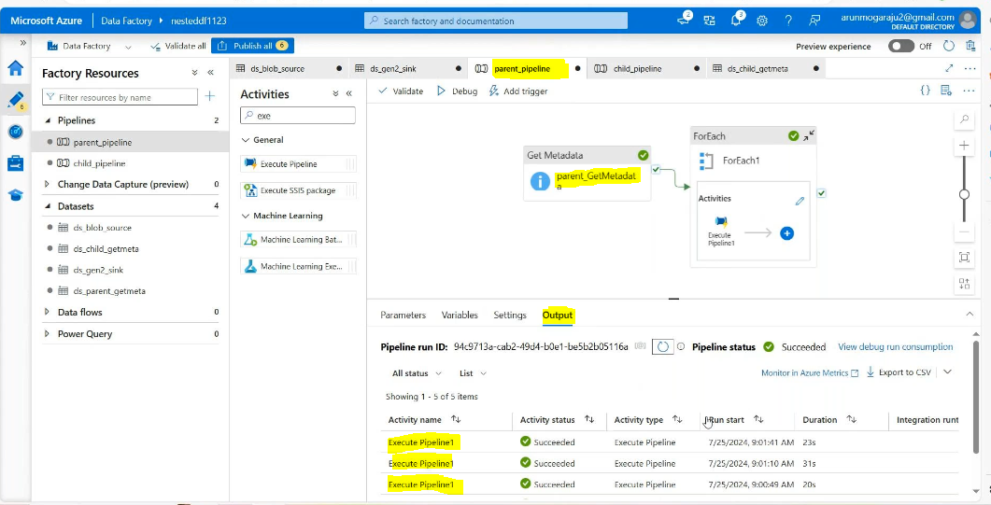

Go to gen2 :

